September 14th, 2008
Hi
So, a surprise letter this week as I have not gone to Indonesia as expected, the reason being that in the e-mail telling me the dates, the organiser had mistakenly typed ‘Sep’ instead of ‘Nov.’ So I should be going there in November.
Last Sunday, as I mentioned last week, the Legco elections were held. The list I voted for in the NT West (geographical) constituency did not get sufficient votes to elect even the first person on the list. This person was a Legco member in the previous assembly, representing the Social Welfare (functional) constituency, but his party moved him to this geographical constituency ( I don’t know why) where he is less well known. Of the 30 geographical constituencies, the pro-democratic parties got 19 with about 65% of the vote. However, they only got 4 of the 30 functional constituency seats which are dominated by pro-government groups, especially from the business sector. So, the pan-democrats are still the minority in Legco though they have sufficient numbers to exercise a veto power over bills. The big loser in the election was the (so-called) Liberal party, which is very pro-business and pro-government; they lost all their geographical constituency seats but still have five (?) functional constituency seats. There is a very strong anti-business sentiment in HK (which includes me) as big companies are perceived, rightly or wrongly, as controlling the government, and are also involved in many deals that favour them and not HK at large. The results also show that a sizable majority of people here want a fully-democratically elected Legislative Council.
Also in HK, the second fireman killed in the Mongkok blaze was buried.
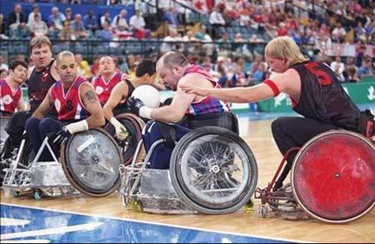
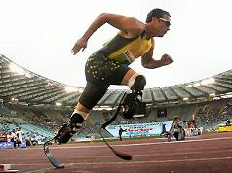
The Paralympics finishes today. I saw some of the events. Quite interesting actually. The South African runner Oscar Pistorius, he with the two blades in place of lower legs (picture – though not at the games?), won two gold medals. His teammate, the girl who also participated in the summer Olympics, won four gold medals. I found out a bit more about Wheelchair Rugby (picture) from the newspaper. It originated in the US and was called “murderball” due to its almost gladiator-like combat, but that name was not thought to be appropriate for an Olympic sport so it was changed to ‘Rugby’ (even though they use a volley ball). However, I think the original name is an accurate description! China, as expected, won the medals tally. China has about 85 million disabled people and the real test will be to see if attitudes towards them change as they are usually hidden away and shunned by society.
I read a Stanford article which said that their athletes won 25 medals at the summer games – 8 gold, 13 silver and 4 bronze). If they were a country, this would place them 9th in the table. This was their best result, the previous best being 21 medals in the Paris 1924 games. The total number of medals won by Stanford students now stands at 218.
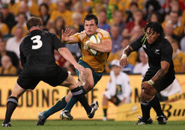
On Friday evening, the hotel held its annual mid-autumn festival poolside party. The atmosphere was not as good as in previous years, possible due to there being few guests attending and not having a band to provide music. Still, the food was OK.
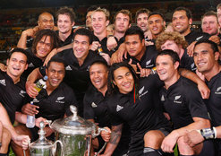
Yesterday, I watched on TV the final and deciding tri-nations match. NZ beat Australia 28-24 (four tries to three) in a very exciting match to take their 4th consecutive tri-nations title and their 9th since the tournament began in 1996. After about 50 minutes, NZ were down 17-7, but in a 17-minute second-half blitz scored three converted tries. The game also gave NZ a 2-1 lead in the Bledisloe Cup. The final Bledisloe Cup match will be held in Hong Kong on November 1st).
Some bad news coming from the US with the train crash in LA and the hurricane in Texas. Also, I don’t know what you think, but I haven’t yet got a good impression of Sarah Palin. This also comes across from reports in the latest TIME magazine, including those by conservative commentators. There also seems to be a lot of irrational acceptance of her by women simply because she is female.
That seems to be it for now.

Cheers

